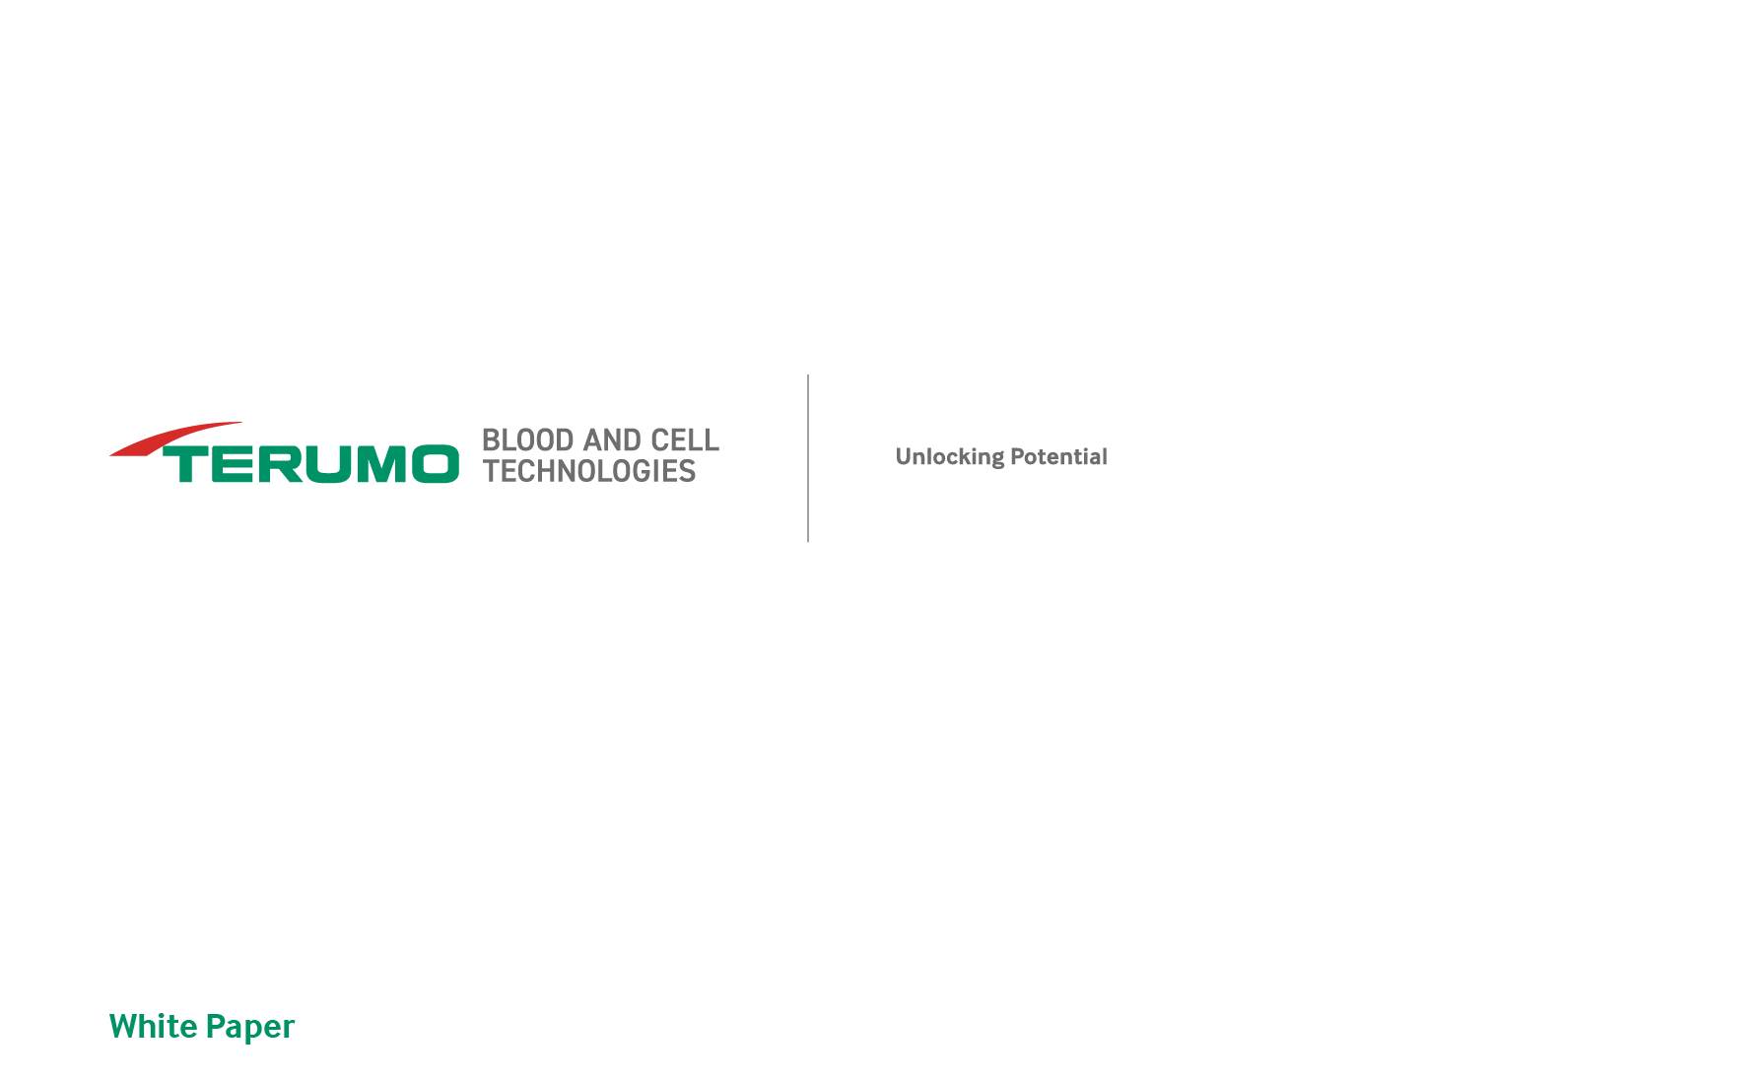
White Paper
Cell Collection Basics — Introduction and Fundamentals for the Transplant and Cell and Gene Therapy Industries
Terumo Blood and Cell Technologies
Summary
Learn about the basics of cell collection starting with the role the peripheral blood stem cells (PBSCs) and lymphocytes play in medical treatments like CAR T-cell therapies and hematopoietic stem cell transplantation (HSCT). Gain insight into common terminology, the importance of starting with high-quality materials, a basic overview of requirements, and tools such as data analysis that help navigate a rapidly growing field. This paper will provide the fundamentals to help healthcare professionals, biotech companies, and manufacturers in their ever-important work toward advancing cell-based therapies for patients worldwide.
Introduction
The collection of peripheral blood stem cells (PBSCs) and lymphocytes has become integral in medical procedures such as chimeric antigen receptor (CAR) T-cell therapies and hematopoietic stem cell transplantation (HSCT). Cell collections provide the fundamental sources of starting material for these curative therapies, driving progress in the fields of hematology and immunology.

PBSCs required for HSCT can be harvested either directly from the bone marrow or from the blood (via leukapheresis) following hematopoietic stem cell (HSC) mobilization. PBSCs can also be obtained from the umbilical cord blood of newborns. But umbilical cords produce only a small amount of blood, which might not have enough cells for an adult. This type of transplant is generally used for children and small adults.

The leukapheresis procedure involves passing blood through an apheresis system that removes the white blood cells and returns all the red blood cells and plasma to the bloodstream of the patient or donor. Whether these cells are obtained through an autologous or allogeneic method, PBSCs play a key role in restoring a patient’s hematopoiesis.

Leukapheresis collection of lymphocytes is becoming more of a common practice due to the increasing development of licensed and clinical trial CAR T-cell products¹. As a result, there is a need for streamlined and reproducible manufacturing methods to facilitate large-scale production.

While manufacturing methodology remains a critical focus, significant bottlenecks such as insufficient cell collection and poor-quality starting material often stand in the way of progress and production of these therapies at scale.

In this paper, we will provide the fundamentals of cell collections to help healthcare professionals, biotech companies, and manufacturers in their ever-important work toward advancing cell-based therapies for patients worldwide.
Common Terms and Definitions
Cell collection, in the context of HSCT and CAR T-cell therapies, involves several core principles and terms. Below are some common terms you may come across, along with their definitions:
- Anticoagulant: An agent used to prevent blood clot formation.
- Apheresis: A procedure in which a patient’s blood passes through a device that separates out a particular blood component and returns the remainder to the patient.
- Buffy coat: A blood fraction containing white blood cells and platelets.
- CAR T-cell therapy: A treatment involving the modification of a patient's T cells to attack cancer cells.
- CD3+: A marker of T lymphocytes (or T cells) derived from CD34+ cells.
- CD19+: A marker of B lymphocytes (or B cells) derived from CD34+ cells. Also, a common target for B cell malignancies treated by CAR T-cell therapies.
- CD34+: A marker of PBSCs, also known as HSCs, and clinically important cells for procedures like bone marrow transplants.
- Collection preference (CP): A reference number used by the Spectra Optia® Apheresis System to adjust plasma pump flow rates.
- Continuous mononuclear cell collection protocol (CMNC): A protocol for continuously pumping target cells from the centrifuge to the collection bag.
- Cryopreservation: The process of preserving biological materials by cooling them to low temperatures.
- Extracorporeal volume: The volume of a patient's blood outside their body during apheresis.
- Granulocyte: A white blood cell type containing granules with enzymes.
- Hematopoietic stem cell (HSC): An undifferentiated stem cell giving rise to other stem cells.
- Lymphocyte: A white blood cell type developed in the bone marrow and thymus. It is found in the blood and lymph tissue to help fight against infection and cancer.
- Mobilization: A process that employs drugs to move stem cells from the bone marrow into the bloodstream.
- Mobilized patients: Patients receiving drugs to move bone marrow into the bloodstream.
- Monocyte: A type of white blood cell that turns into macrophages or dendritic cells when germs enter the body.
- Mononuclear cell collection protocol (MNC): A protocol that cycles through accumulation and collection phases.
- Non-target cells: Cells collected along with target cells that can impact the final product.
- Peripheral blood stem cell (PBSC): Early-stage hematopoietic cells critical for blood cell production, collected from peripheral blood.
- Platelets: Small cell fragments involved in blood coagulation.
- Vascular access: The method used to gain access to a patient's venous system during apheresis.

Cell Collection Basics
Cell collections are built upon an intricate process. Within this process, and depending on the type of procedure, the collection of specific blood components such as PBSCs (also known as stem cells) and lymphocytes occurs. And each cell type has its own distinct role and characteristics.

PBSCs are the architects of regeneration within the human body. In fact, they can even develop into more blood-forming, specialized cells — making them a versatile resource for therapeutic treatments.

Three primary categories of stem cells are recognized today:
- Embryonic stem cells: These versatile cells can form nearly any cell type in the body.
- Adult stem cells: These more specialized cells are found in specific tissues where they contribute to tissue maintenance and repair.
- Induced pluripotent stem cells: Induced pluripotent stem cells are adult cells derived from the skin or blood and have been reprogrammed into an embryonic-like pluripotent state.

Lymphocytes are an important component of the immune system. These white blood cells are primarily produced in the bone marrow and further mature in lymphoid tissues (such as the thymus, spleen, and lymph nodes).

Lymphocytes are divided into two main categories:
B lymphocytes: Responsible for producing antibodies, which help recognize and neutralize foreign substances (antigens).
T lymphocytes: Involved in cell-mediated immunity, including the direct targeting and destruction of infected or abnormal cells.
T lymphocytes are further categorized into T helper cells (CD4+), cytotoxic T cells (CD8+), and regulatory T cells (Tregs). Each has a specific function within the immune response. In the context of cell collection, T lymphocytes are collected through apheresis for therapeutic purposes, including CAR T-cell therapies and HSCT.

In the case of CAR T-cell therapies, T lymphocytes are engineered into therapeutic agents to provide immune-regulating functions and target specific diseases. This is why the success of the collection and preservation of T lymphocytes is critical for therapeutic effectiveness and outcomes.
Overview of Cell Collection Requirements
The fast-growing landscape of cellular-based therapies has created even higher stakes for patient outcomes and cellular starting material success. In recent years, cellular-based therapy has been incorporated into the regulatory guidance around donor identification, cell collection, cell therapy manufacturing, and administration.

Guidance includes country-based guidelines such as those from the U.S. Food and Drug Administration (FDA) as well as from voluntary accreditation groups like the Foundation for the Accreditation of Cellular Therapy (FACT), the Joint Accreditation Committee of the International Society of Cellular Therapy (JACIE), and EBMT (formerly known as the European Society for Blood and Bone Marrow Transplantation). Together, these regulatory guidelines help establish effective standard operating procedures and quality management systems to enable safe and effective cellular collection, manufacturing, and infusion for donors and patients.

The cell collection process requires the expertise of apheresis device operators, adequate access to the bloodstream, and specialized cell separator platforms, such as the Spectra Optia Apheresis System.

As the field continues to rapidly expand, the importance of data analytics and prediction algorithms becomes increasingly apparent. These tools become a bridge for more visibility into the apheresis process. Additionally, the utilization of data analytics and prediction algorithms helps to:
- Identify methods for determining the optimal blood volume to process
- Optimize collection approaches
- Improve performance across multiple sites for process efficiency
- Increase the quality and yield of starting material
Significance of High-Quality Starting Material
Cell collection by apheresis is one of the critical first steps of the cell therapy manufacturing cycle. Approximately 80% of engineered cell therapy clinical trials involve the collection of cells through apheresis.^{2,3} Therefore, the need for high-quality starting material is important to the downstream success of manufactured cell therapies, because the number of healthy cells in leukapheresis-derived starting material directly impacts the efficacy of the final product.⁴

There are many factors that influence the quality of the collected products being used as the starting materials for cell therapy manufacturing: variability due to the patient or donor, operation of the apheresis collection itself, and post-collection processing and storage of the collected cells.

The variability of cells collected is influenced by several factors, including:
- Unique patient characteristics
- The expertise of the operator conducting the collection
- The specific protocols used by each collection site

These differences influence the contents and quality of the starting materials in terms of target cell yield and viability, product volume, and product purity, determined by the number of contaminating cells contained within each product.⁵ If any of these variables do not meet ideal parameters, the downstream manufacturing processes may be impacted, and this increases the chances of having insufficient cells for the recommended treatment dosage.⁴

Different centers may follow their own protocols, potentially affecting the quality of starting materials. Achieving consistency across all sites and operators is essential for effective therapeutic and manufacturing processes to support expansion and enable accessibility of cell-based therapies.
Thus, consistency allows us to maximize the number of patients who benefit from these therapies.
Conclusion
CAR T-cell treatments and HSCT rely heavily on the quality of starting materials derived from cell collections. Understanding and addressing the intricacies of T-cell collection, such as optimizing the collection process, can directly impact manufacturing outcomes and, ultimately, patient outcomes.
Key Takeaways
- Leukapheresis collection of lymphocytes is becoming more of a common practice.
- PBSCs are vital for autologous and allogeneic HSCT.
- High T-cell collection yields are critical to CAR T-cell therapy manufacturing.
- The collection of quality starting materials is a crucial phase in cell-based therapies, with patient outcomes reliant on its success.
- Leveraging data analytics and algorithms can help optimize and bring consistency and quality to the cell collection process.
- Addressing the complexities of cell collection directly influences patient outcomes and the advancement of life-saving therapies.

While the pace of advancements in collection techniques may vary, the urgency to overcome cell collection-related challenges remains constant. That’s why it’s important to keep exploring and understanding cell collections — the methods, requirements, challenges, and existing solutions.
Next white paper:
Cell Collection Basics — Understanding Cell Collection Methods, Challenges, and Solutions for the Transplant and Cell and Gene Therapy Industries

Request your copy of our next white paper:
Reach.Terumo-BCT.com/Sign-Up-For-White-Paper

Apheresis Collections
Contact Us for the Support You Need
At Terumo Blood and Cell Technologies, our apheresis and data analytics experts help cell manufacturers, hospitals, and third-party collectors demystify, navigate, and improve the detailed landscape of their apheresis cell collections. Through our Veda Solutions program, we offer data services related to Spectra Optia collection procedure parameters. We offer solutions designed to bring control and consistency to your process — improving the quality of your starting material and process for safe, predictable procedures.

vedasolutions@terumobct.com
TerumoBCT.com/VedaSolutions

References
- Hunt TD. 2023 industry update; presented at the Alliance for Regenerative Medicine Cell & Gene State of the Industry Briefing; January 9, 2023; San Fransisco, Calif.:
- Alliance of Regenerative Medicine. (2018). Annual Regenerative Medicine Data Report 2018. https://alliancerm.org/publication/2018-annual-report/. Accessed October 20, 2023.
- Heathman TR, Nienow AW, McCall MJ, Coopman K, Kara B, Hewitt CJ. The translation of cell-based therapies: clinical landscape and manufacturing challenges. Regen Med. 2015;10(1):49-64.
- Juliano L, Eastwood G. The importance of collection, processing & biopreservation best practices in determining CAR-T starting material quality. Cell Gene Ther Insights. 2018;4(4): 327-336.
- Purtill D, Smith K, Devlin S, et al. Dominant unit CD34+ cell dose predicts engraftment after double-unit cord blood transplantation and is influenced by bank practice. Blood. 2014;124(19):2905-2912.



Terumo BCT, Inc.  10811 West Collins Ave.  Lakewood, Colorado 80215-4440  USA  USA Phone: 1.877.339.4228  Phone: +1.303.231.4357  Fax: +1.303.542.5215 | Terumo BCT Europe N.V.  Europe, Middle East and Africa  Ikaroslaan 41  1930 Zaventem  Belgium  Phone: +32.2.715.0590  Fax: +32.2.721.0770 | Terumo BCT Asia Pte. Ltd.  89 Science Park Drive  #04-25 (Lobby B)  The Rutherford  Singapore 118261  Phone: +65.6715.3778  Fax: +65.6774.1419 | Terumo BCT Latin America S.A  La Pampa 1517–12th Floor  C1428DZE  Buenos Aires  Argentina  Phone: +54.11.5530.5200  Fax: +54.11.5530.5201 | Terumo BCT Japan, Inc.  Tokyo Opera City Tower 49F,  3-20-2, Nishi-Shinjuku,  Shinjuku-ku, Tokyo 163-1450,  Japan  Phone: +81.3.6743.7890  Fax: +81.3.6743.9800
TERUMOBCT.COM
©2022-2024 Terumo BCT, Inc. TS-OPTI-02275

